PARTNERS
Dr. H. Jayasinghe MB CHB MRCGP
Male (GMC Number 4474250)
Dr.C Ostler MBBS MRCGP MRCP DFSRH Dip Dermatology
Female (GMC Number 6026862)
Dr. A Sornum MBBS MRCGP MRCP MPH DTMH
Male (GMC Number 7044494)

Chapeltown Family Surgery

Tel: 0113 240 7000
Email: chapeltownfamilysurgery@nhs.net
Website: www.chapeltownfamilysurgery.nhs.uk

PRACTICE OPENING HOURS
Our Reception is open weekdays between 08.30am – 18:00pm Monday to Friday
We are closed on weekends and bank holidays.
CCTV / CALL RECORDING
We operate a CCTV system for the security of its patients and staff. Calls are recorded for the benefit of both patients and staff.

DISABLED ACCESS
Automatic Front Door Access suitable for wheelchairs. Disabled toilets in the waiting room.

LANGUAGE SERVICES
We have access to interpreters via telephone if needed. We can also book in-person translators for your appointment in advance. Please enquire at reception.

FACILITIES
Toilets and baby changing facilities are located near reception. There is a pharmacy on site.

The surgery operates a no smoking policy in its building and grounds

The car park is available for patient use and is at your own risk. There are two disabled bays near the entrance. The practice accepts no liability for any losses or damage caused whilst parked on its premises.

SURGERY TIMES

Our usual appointment times are available
Monday to Friday 08:30-11:30 and 14:00 – 17:00. Appointments with our HCA and Nurses may fall outside of these times.
A limited number of out of hours appointments are available for URGENT ON THE DAY NEEDS in our partner surgeries in the area.

PRACTICE STAFF
Practice Manager Carole Jones
Practice Nurses Sarah Fryer, Alison Walker
Healthcare Assistant Laura Shearer
Reception Lead Nisrain Bashir
Receptionists Maddie, Holly, Morgan,
Ebenezer, Chloe
Secretary Nadia Abolitis

TRAINEES AND STUDENTS
We are a training practice and regularly have GP Trainee doctors and medical students working with us. If you do not want to see a trainee please let the reception know.

LEAFLETS
You will find a wide variety of Practice Leaflets which will inform you of all the services that we provide for our patients in our waiting room. These include a Patient Charter Leaflet and Comments and Complaints leaflets.
HOW TO REGISTER AS A PATIENT
The practice welcomes new patients from within its catchment area. To join the practice, all that is required is the completion of a straight forward joining form - you do not need to inform your current GP that you are leaving - your notes will be transferred straight to our practice. Once you have registered you will be offered a comprehensive new patient medical check.

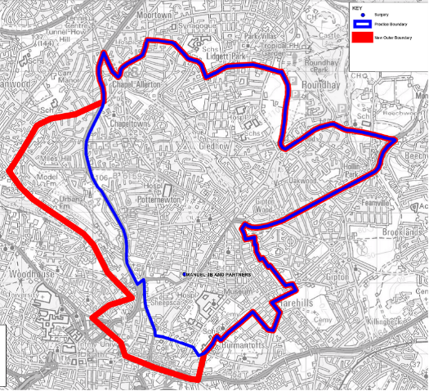

APPOINTMENTS
Appointments can be by telephone, online or in person. Our doctors each have a number of routine pre-bookable slots and urgent on-the-day appointments.

If you would like an urgent on the day appointment please call or visit the reception at 08:30am. These appointments are for new problems, and not for sick notes, letters or routine issues.

Please remember to cancel all unwanted appointments.

HOME VISITS
Home visits should only be requested for those who are unable to come to the Surgery because of serious illness and frailty. They should be requested before 10.30 if at all possible.

PRESCRIPTIONS
If you are on repeat medication, please use the reordering slip attached to your repeat prescription. Remember to tick the boxes for the items required.
Requests for all medications can submitted:
- Over the phone – after 10am.
- On line
- By hand to the reception
- By Post
- Dropped in the box by reception

Requests do take 72 hours to be completed. If you have an urgent need, please speak to reception.

CHAPERONES
All patients are entitled to have a chaperone present for any consultation. Please request this at the time of booking or speak to your GP.

TEST RESULTS
You can request a text message or a telephone appointment for your test results to be given for blood and x-ray results

SERVICES AVAILABLE
We offer many services including:
- Childhood Immunisation
- Influenza Vaccinations
- Travel Vaccinations
- Cervical Screening (Smears)
- Family Planning
- Baby checks
- Referral to Smoking Cessation Services
- Weight Management Support
- Well Person and General Health Checks
- Chronic Disease Management Clinics
- Private Medicals e.g. HGV, Taxi Medicals
- Blood tests

OUT OF HOURS
Out of hours, the surgery number is diverted to the 111 answering service. Patients may also attend Out of Hours appointments through 111 or the Walk In Centres. Please see https://www.leedsth.nhs.uk/stay-well/urgent-treatment/ for more information.

COMMENTS AND COMPLAINTS
Comments on any aspect of the practice are always welcome. If you have any suggestions or are unhappy about any aspect of our service, write them down and drop them in our suggestion box in the reception. If you wish to make a formal complaint against us, we operate the NHS complaints procedure: any letters of complaint should be addressed to the Practice Manager.

